# Matthew Clockel

# Southern New Hampshire University

# 10 February 2021

# IT 315 – 21EW3

# Professor Mustafa

# IT 315 Final Project Part III Solution Submission

**Name:** Matthew Clockel

**Date:** 2/10/2021

1. Generate your student information system (SIS) sequence diagram for the Register a Student for Classes use case.

Generate your SIS communication diagram for the Register a Student for Classes use case.

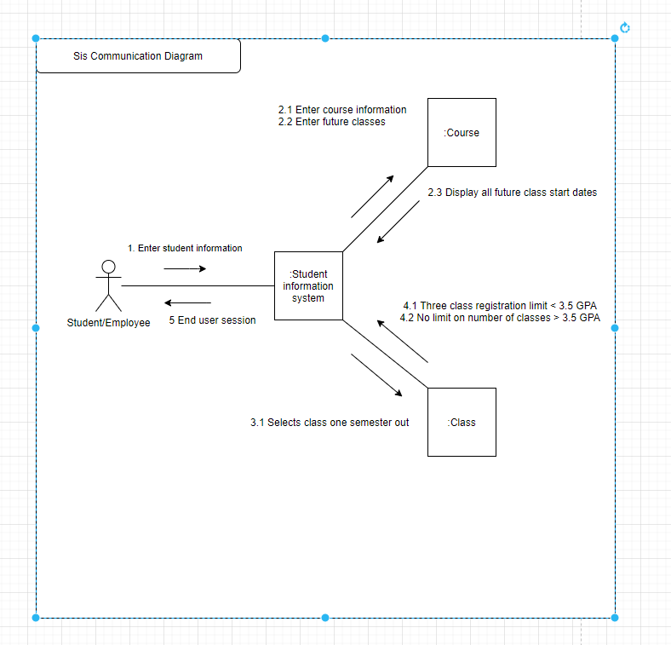

**SIS Method Contract 1 template** (refer to textbook pages 306–314):

|  |  |  |
| --- | --- | --- |
| Method Name:  Course selection | Class Name:  Course Records | ID:  1 |
| Clients (Consumers):  Employee, Students | | |
| Associated Use Cases:  Student records, Class records | | |
| Description of Responsibilities:  Enters course information to identify the course to register for. | | |
| Arguments Received:  One semester out | | |
| Type of Value Returned:  Future class start dates | | |
| Pre-Conditions:  Student information to identify registering student | | |
| Post-Conditions:  Class registration validation | | |

**SIS Method Contract 2 template:**

|  |  |  |
| --- | --- | --- |
| Method Name:  Class selection | Class Name:  Class Records | ID:  2 |
| Clients (Consumers):  Employee, Students | | |
| Associated Use Cases:  Student records, Course records | | |
| Description of Responsibilities:  Selects the proper number of classes based on the student’s GPA. | | |
| Arguments Received:  Validation that there are no duplicate registrations. Online class requirements. Class limits | | |
| Type of Value Returned:  Confirmation displayed or message explaining violation of the associate rules. | | |
| Pre-Conditions:  Student information to identify registering student | | |
| Post-Conditions:  Process continuation or end user session. | | |

**SIS Method Specification 1 template** (refer to textbook pages 314–318):

|  |  |  |
| --- | --- | --- |
| Method Name:  Course selection | Class Name:  Course records | ID:  1 |
| Contract ID:  1 | Programmer:  McDeveloper007 | Date Due:  2/15/21 |
| Programming Language:  Java | | |
| Triggers/Events:  Student and course information is entered. | | |

| **Arguments Received:**  **Data Type:** | **Notes:** |
| --- | --- |
| Limits to one semester out  Displays only future courses | Past classes are not displayed. |

| **Messages Sent & Arguments Passed:**  **ClassName.MethodName:** | **Argument Data Type:** | **Notes:** |
| --- | --- | --- |
| Student ID entered  Course ID entered  Class begin date | int | Student ID |
| int | Course ID |
| Int/date | Class begin date |

| **Argument Returned:**  **Data Type:** | **Notes:** |
| --- | --- |
| Duplicate registration | Returns error when duplicate class is selected |
| Algorithm Specification:  Verification against the registration rules | |
| Misc. Notes:  No duplicate registrations for the same class in one semester | |

**SIS Method Specification 2 template:**

|  |  |  |
| --- | --- | --- |
| Method Name:  Class selection | Class Name:  Class records | ID:  2 |
| Contract ID:  2 | Programmer:  McDeveloper007 | Date Due:  2/15/21 |
| Programming Language:  Java | | |
| Triggers/Events:  Class selection is entered. | | |

| **Arguments Received:**  **Data Type:** | **Notes:** |
| --- | --- |
| Duplicate registration  Online class requirements confirmation  Class limit based on GPA | Students with GPA > 3.5 have no limit on number of classes. |

| **Messages Sent & Arguments Passed:**  **ClassName.MethodName:** | **Argument Data Type:** | **Notes:** |
| --- | --- | --- |
| Duplicate registration  Online class requirements  Class limit | String | No duplicate classes |
| String | Hardware and software requirements |
| String | GPA requirments |

| **Argument Returned:**  **Data Type:** | **Notes:** |
| --- | --- |
| Validation requirements | Returns error when duplicate class is selected |
| Algorithm Specification:  If GPA is < 3.5 limit to three classes, else no limit to classes | |
| Misc. Notes:  Confirmation is displayed to confirm registration or message explaining violation of the rules | |

1. Verify and validate your sequence diagram and communication diagram against your SIS functional model and structural model.

I have validated and verified the sequence and communication diagram against the SIS models. The student information must be entered to identify the registering student. The course information is used to identify the course to register for. The future classes are then returned with the dates. The enrollment staff selects the class to register for. The class registration is then validated based on the guidelines. The guidelines include no duplicate registration for the same classes. Online registration requires hardware and software the access the online classes. The student’s GPA must be greater than 3.5 to register for more than three classes. These are the steps involved with registering a student for classes and are validated into the diagrams listed above.

1.Explain your approach to the problem, the decisions you made to arrive at your solution, and how you completed it.

The approach I have used was to start from the top and work my way down with this template in order. I started with the sequence diagram comparing this to the SIS requirements to register a student for a class. Once I have completed this sequence diagram, the communication diagram followed. Then the method contract and specifications were completed last. Following this order, I was able to pull the information from the diagrams to put them into the method and specification.

2. Reflect on this experience and the lessons you learned from it.

This assignment was time consuming. I had trouble with the methods and specifications part of the assignment. I have learned how to organize the development of the functionality of software without coding. These diagrams are useful because when one does code the software, the diagrams have the logic broken down into steps and sections. I have also learned that these diagrams will be useful for any software one will develop because they act as a blueprint or foundation of code.